Member: Pham Tuan Kiet, Trinh Huynh Duc

## User: Marketing Coordinator

Goal: Marketing Coordinator can access articles submitted by students who in their faculties. This includes able to view,comment and publish (export).

Triggers: User login using the Marketing Coordinator account

Preconditions: Marketing Coordinator account must exist in the database and accessible.

## Test case:

Login

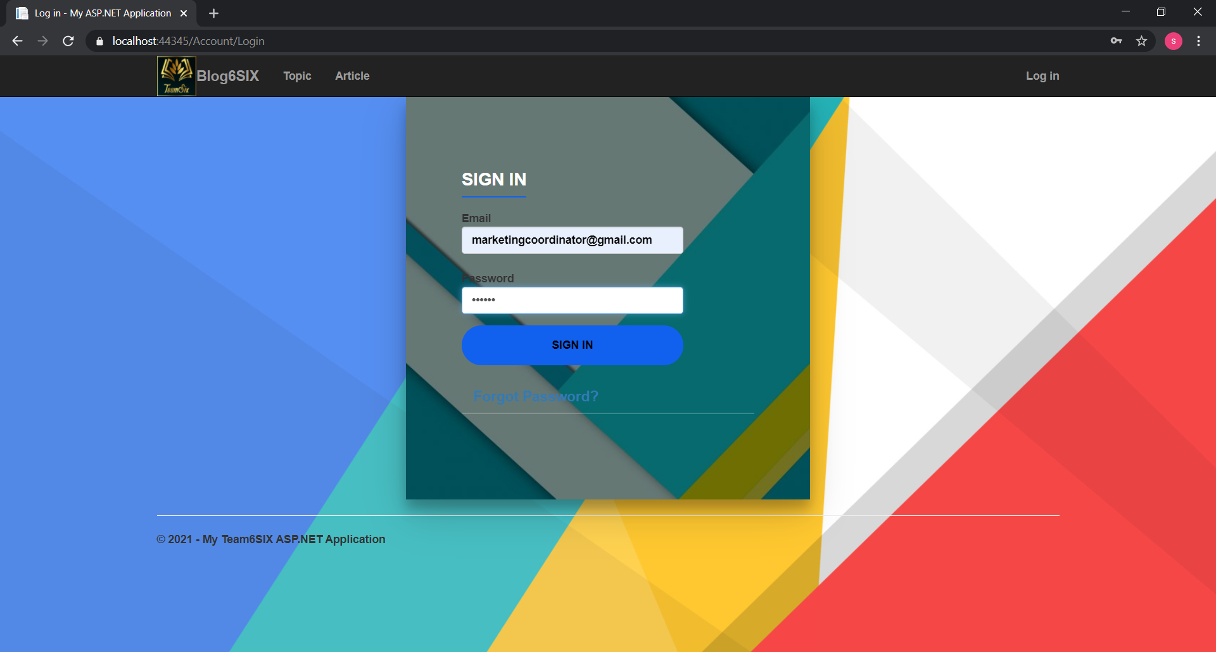

Gmail to check

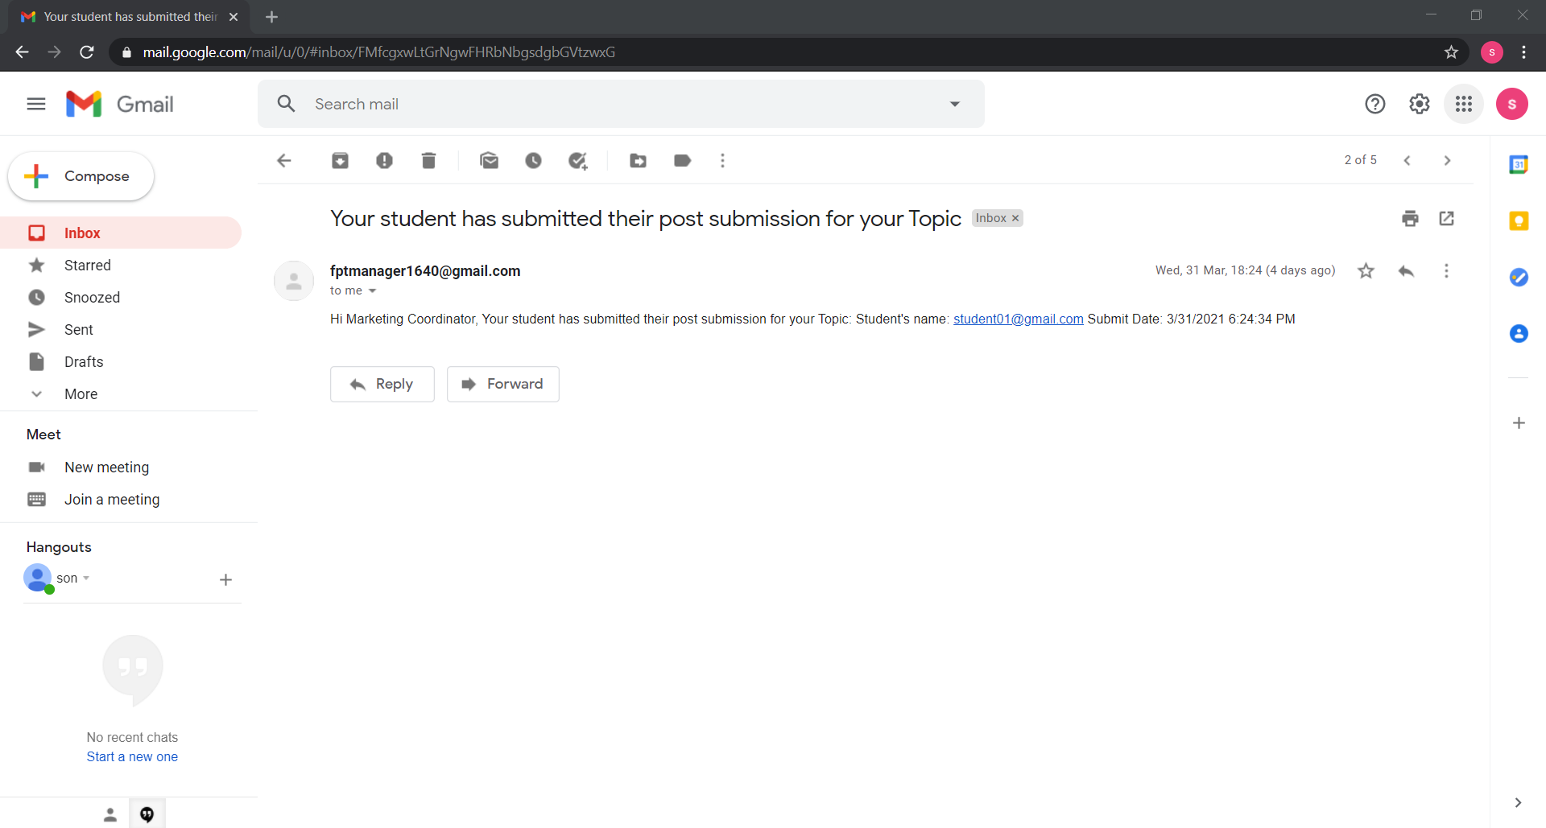

Home Page

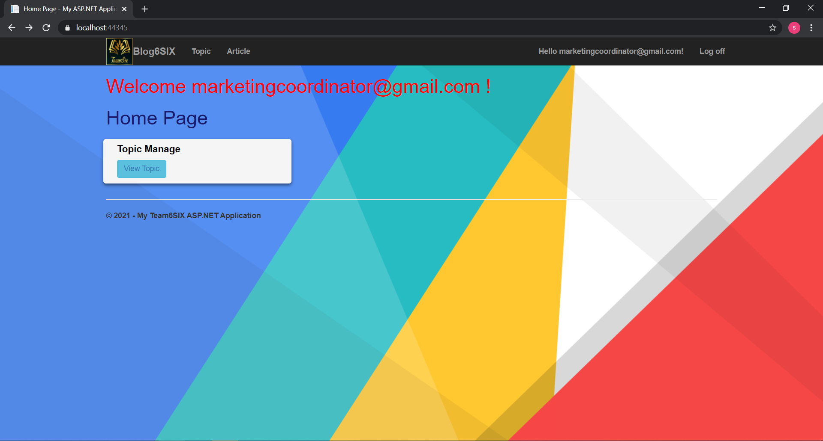

Can Check Topic

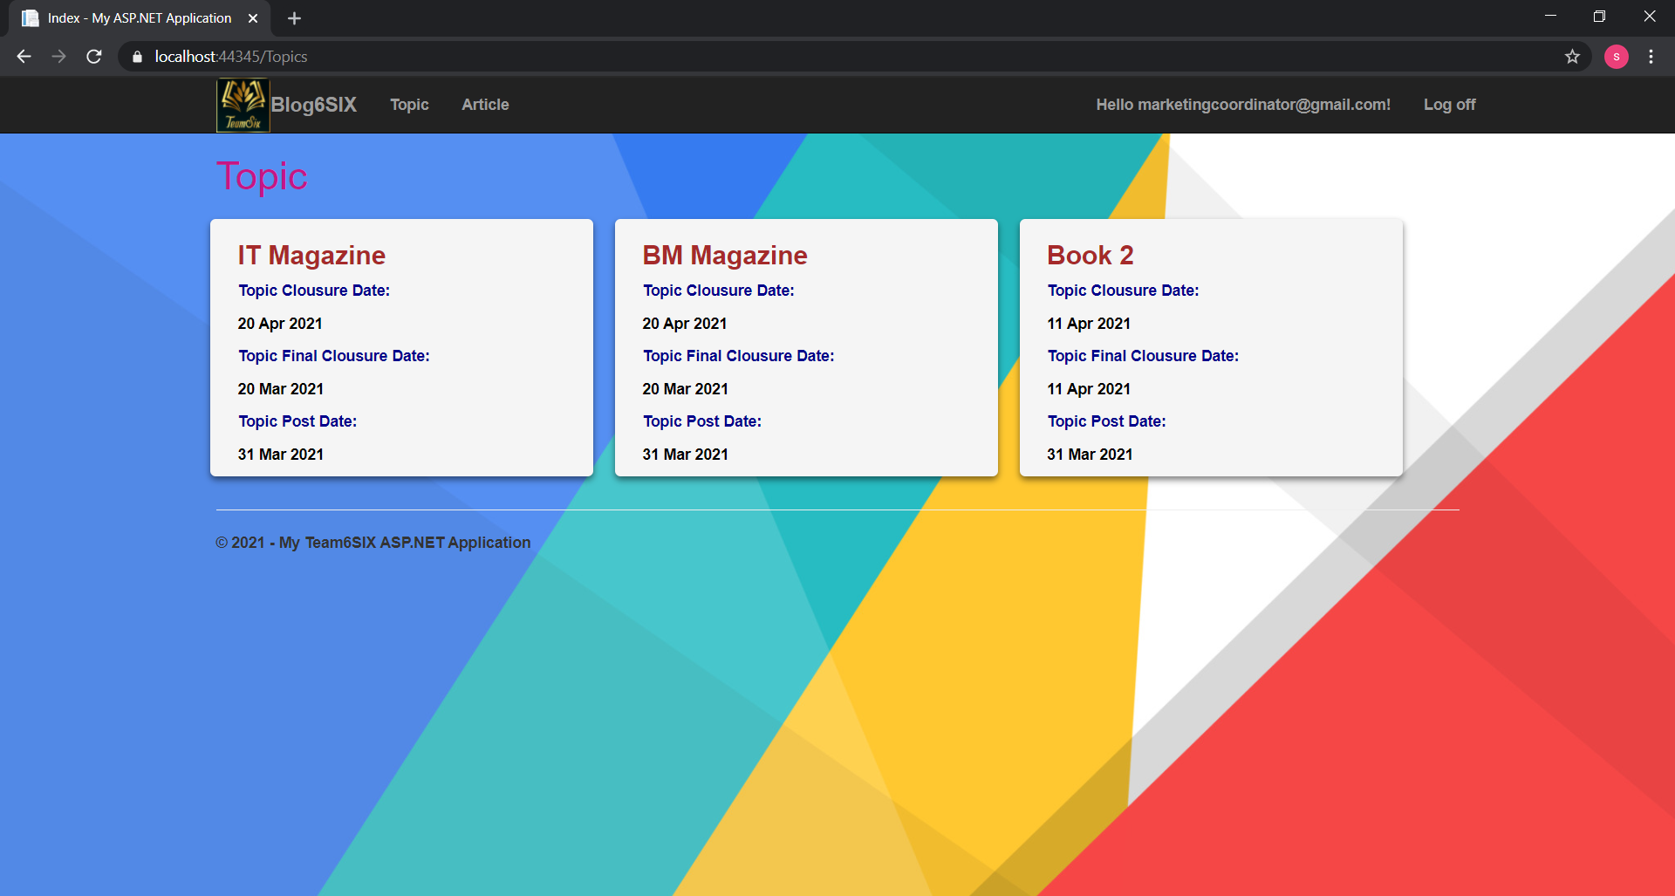

Check All Article

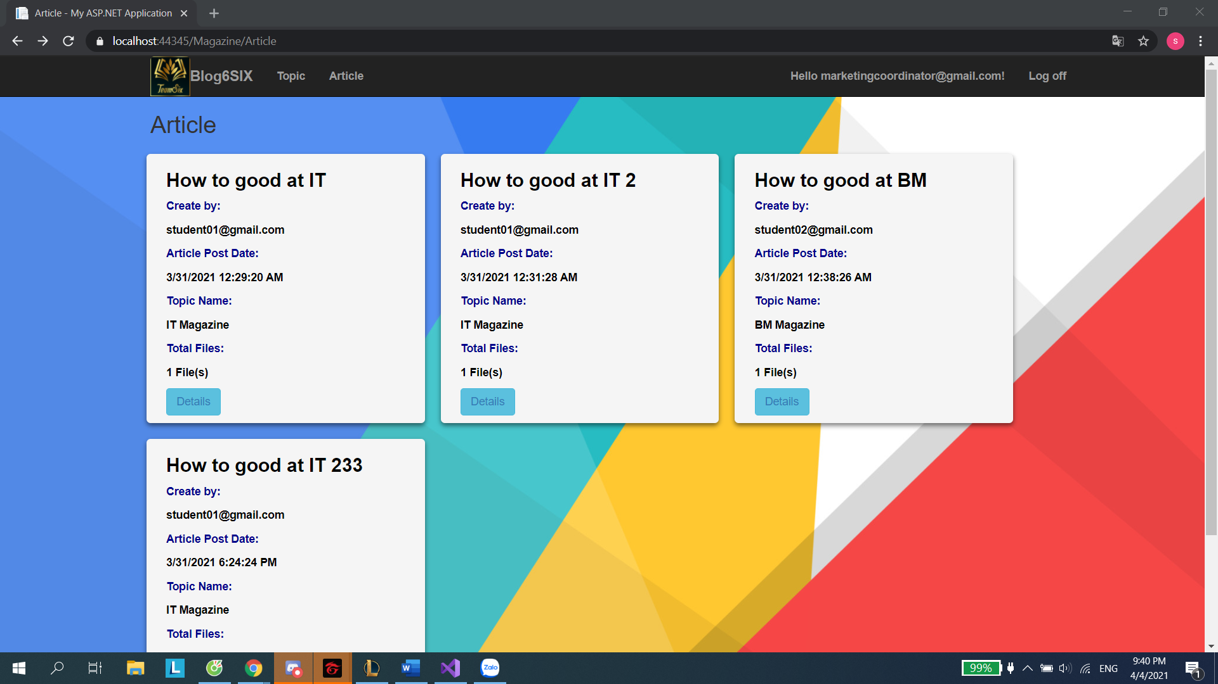

Click To the file and download file

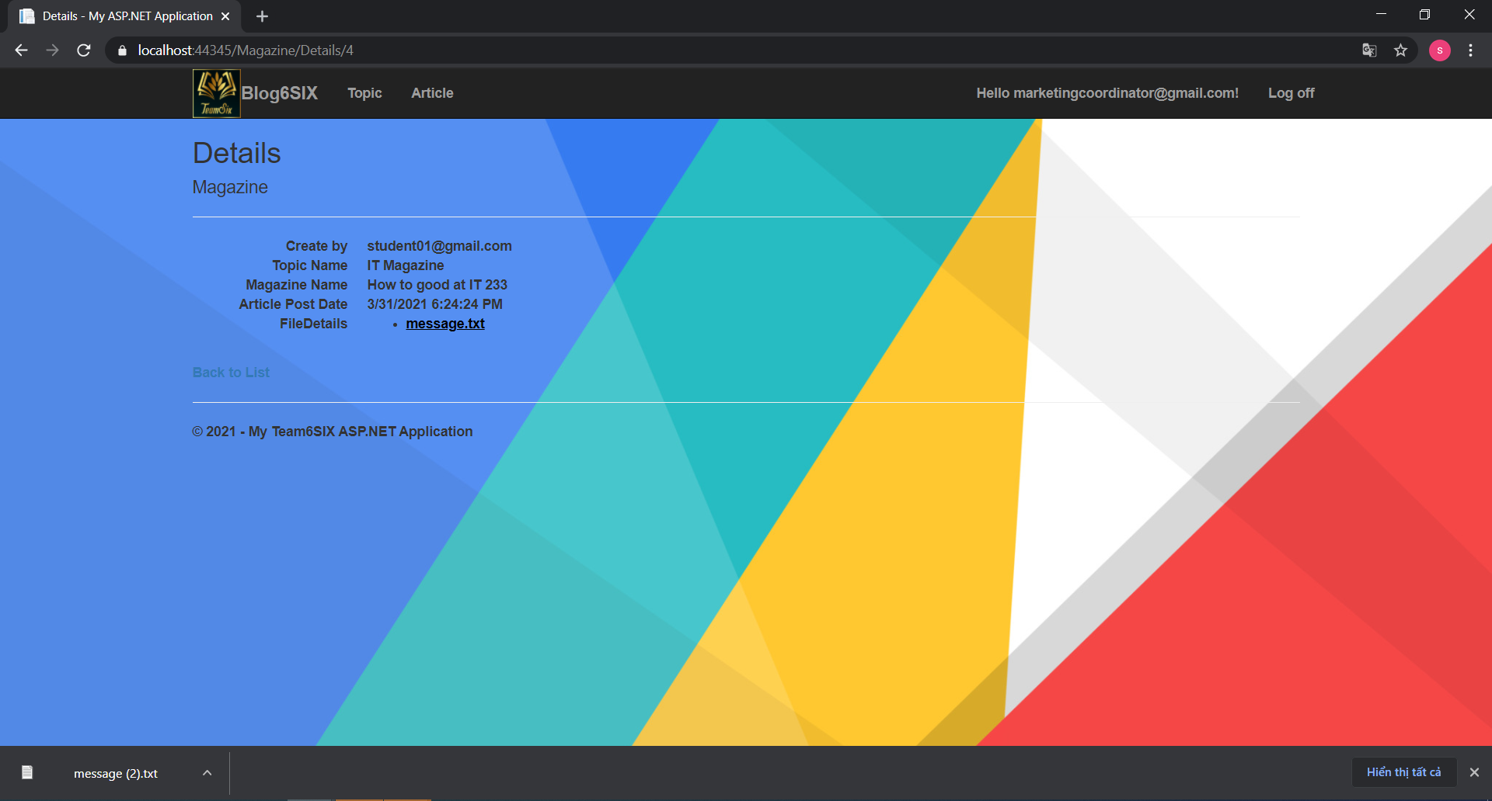

|  |  |  |  |  |  |
| --- | --- | --- | --- | --- | --- |
| **Functions** | **Test Scenario** | **Step Description** | **Expected Result** | **Actual Result** | **Status** |
| Test if Marketing Coordinator can access student’s articles in their faculties | MC can see the articles inside their faculties | 1) Login using a MC account 2) View the default page | All the articles inside their faculties should be displayed | Successful | Pass |
| Test if Marketing Coordinator can access student’s articles in other faculties | MC can NOT see the articles outside their faculties | 1) Create an article using a student account outside the current MC faculties 2) Login using a MC account 3) View the default page | The article should not be displayed | Successful | Pass |
| Test if Marketing Coordinator can edit student’s articles in their faculties | MC can see the articles inside their faculties | 1) Login using a MC account 2) View the default page 3) Choose an article and edit | The system should allow MCs to edit the articles in their faculties | Successful | Pass |
| Test if Marketing Coordinator can delete student’s articles in their faculties | MC can NOT delete the articles inside their faculties | 1) Login using a MC account 2) View the default page 3) Choose an article and delete | The system should make report an appropriate error | Nothing | Fail |
| Test if Marketing Coordinator can select student’s articles in their faculties to publish | MC can publish (export) the articles they like inside their faculties | 1) Login using a MC account 2) View the default page 3) Choose an article and click on the publish button | The article should be downloaded into the MC's local computer for publishing | Nothing | Fail |
| Test if Marketing Coordinator can Comment some student’s articles to Tutorial Student | MC can Comment some student’s articles to Tutorial Student | 1) Login using a MC account 2) View the default page 3) Choose an article and click on the detail button  4) Add Comment and Save | The article should be comment into the MC's local computer for publishing. | Nothing | Fail |